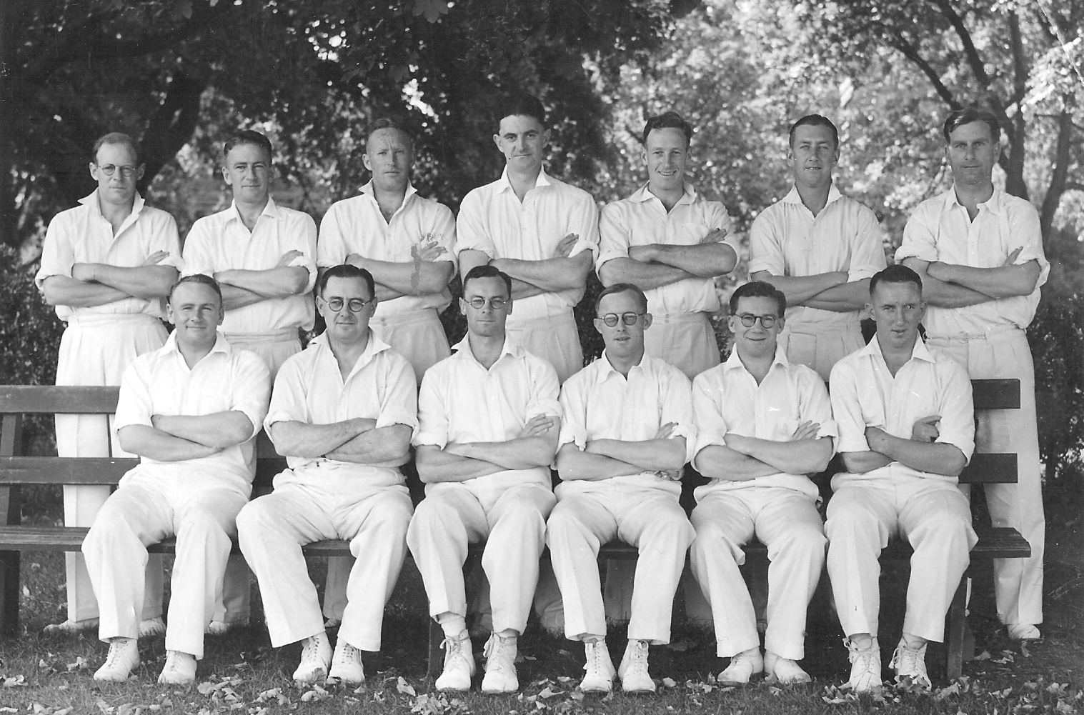

**Canterbury Representative Team 1940-41**

**Back row:** JL Kerr, NV Burtt, LA Butterfield, DAN MacRae, RH Scott, FP O’Brien, M Lohrey

**Front row:** TB Burtt, IB Cromb, WA Hadlee (captain), W McD Anderson, KFM Uttley, J Smith